Praktyka Zarzdzania Procesami Produkcji ¹

The Global Gazette
Official Newsletter of the Global Manufacturing Research Group (GMRG)
Volume 3, Number 2
January, 1997
1. Manufacturing Practices (Polish)

This newsletter is sponsored by the College of Business,
Iowa State University, Ames, Iowa
Benjamin Allen, Dean

Group Statement:
The Global Manufacturing Research Group (GMRG) is a multi-national community of researchers dedicated to the study and improvement of manufacturing practices world-wide. Through systematic study and research throughout the world, the GMRG aims to improve manufacturing practice through the development of theory and dissemination of results. By sharing ideas, results, and concepts with research colleagues and manufacturing executives around the globe, the GMRG serves to strengthen the linkage between research and practice.
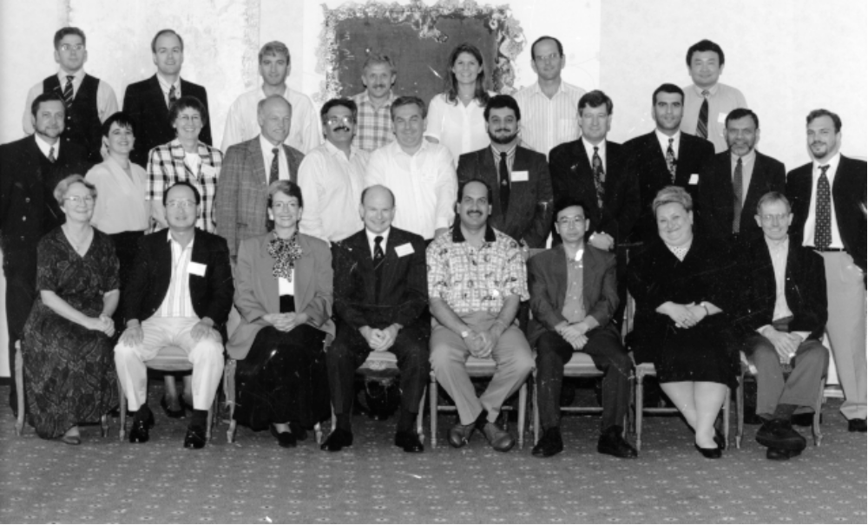

GMRG Meeting at Cranfield, England 1996
Front row: Neva Whybark (USA), Sang Lee (USA), Karen Brown (USA), Clay Whybark (USA), Amrik Sohal (Australia), W.B. Lee (Hong Kong), Danuta Kisperska-Moron (Poland), Lawrie Corbett (New Zealand)
Middle row: Arturo Macias (Mexico), Marcella Macias (Mexico), Linda Sprague (England), Jack Wacker (USA), Danny Samson (Australia), Attila Chikan (Hungary), Zeyad Naji (England), Andrew Johnstone (England), George Moschopolulos (Greece), Basheer Khumawala (USA), Donstantionos Mikedakis (Greece)
Back row: Elliott Grant (England), Robert Klassen (Canada), Pavel Dimitrov (Bulgaria), Cliff Jones(Wales), Lisa Roberts (Wales), Avraham Shtub (Israel), Yongjian Shi (England) (Missed photo session Silvana Trimi (Albania)

News From The Director
Hi there. We enjoyed seeing some of you at the GMRG workshop in Cranfield this summer. Linda Sprague hosted and provided us with an air show in addition to the discussions and plant visits (it was a 50th anniversary celebration at the airfield on the Cranfield campus). The visit to the Cummins Engine factory inspired a research project on manufacturing cells that Simon Hurley and I are conducting here in New Zealand. I'm already looking forward to the meeting that Danuta Kisperska-Moron will host next year in Katowice, Poland. You'll find more on that elsewhere in the newsletter.
During the meeting at Cranfield, Linda Sprague offered to have the Manchester Manufacturing Management Center take over the receipt and distribution of the GMRG data. Everyone agreed that was a good idea and the procedures are now being worked out. Deborah Hodge, who was a Beta site for the data entry program as well as being involved in the data gathering process, is still associated with the center so she can provide some technical expertise. In addition to the change in location for the data, the group decided to work on revising the questionnaire. Jack Wacker is coordinating that activity, so send him any suggestions you might have.
We continue to involve researchers from new countries as the network expands. Several of them are adding to the data base, using the second round survey instrument. Data is now compiled in Canada, Israel and Portugal and should be available soon. I'm still hopeful of getting data from some of the other countries that requested information and the survey form.
Providing feedback to the survey respondents remains an important responsibility for all of us. Rob Klassen reports that he will use a version of the report developed by Linda Sprague (we saw a draft version in Cranfield) to provide information to the Canadian respondents. Several people are using the results of the GMRG data analysis program to provide their respondents with benchmarking information.
A very novel approach for providing feedback was used in Portugal where Jose Fontes invited respondents, trade association representatives and some academics to attend a workshop on the results of the Portuguese survey. In addition to presenting the data, there were industry and academic panels which provided comments on the results and on other issues facing the companies. I have warned Jose that I will steal the idea and use it myself. It seems that gathering industry people together for collecting the data and for disseminating the results has proved a very useful means for increasing the sample size and for providing valuable feedback to the cooperating firms.
The current version of the survey offers a rich harvest of research opportunities. For example, the addition of the new performance variables has opened the possibility of replicating a number of other studies which relate practices to performance. One such study is the Australia/New Zealand survey that was discussed at the GMRG workshop in New Zealand in 1995 and on which Danny Samson reported at the meeting in Cranfield. There are relationships in the GMRG data that confirm some of the findings from the Australia/New Zealand study. A preliminary analysis of some of these relationships was presented at the Cranfield meeting by Lawrie Corbett.
Our work has attracted the attention of the New Zealand Ministry of Commerce and they have mounted a ground-breaking survey of New Zealand manufacturing. The project will involve the organization responsible for gathering national statistics. The project is spearheaded by Doug Galwey, whom several of you met when he joined us at the New Zealand and Cranfield workshops. The use of the national statistical organization provides an unprecedented linkage to official financial data for doing the analysis of the relationships between practice and performance.
There are many other unexplored avenues provided by the data in the second survey. To the best of my knowledge nobody has used the added value measure that is now available. Studies that confirm or deny the importance of using value added instead of sales would be welcome. Moreover, I know of only a few temporal studies that compare data from the first to the second survey. Studies that indicate the rapidity of change over time or where there are relatively stable practices would also be useful. For GMRG purposes, such studies would help in determining the frequency with which the survey should be conducted and for focusing on variables that seem to change more frequently and/or more dramatically.
The special issue of JOM on empirical research is being finalized. Danny Samson says most of the papers are nearing completion and that the GMRG is well represented. Congratulations to all of you who had a paper accepted.

The Global Gazette
Vol. 3., No. 2.
January, 1997
The Global Gazette is the Official Newsletter of The Global Manufacturing Research Group.
Global Manufacturing Research Center
Kenan-Flagler Business School
The University of North Carolina
Chapel Hill, NC. USA 27599-3490
Professor D. Clay Whybark, Director
Professor John G. Wacker, Newsletter Editor

About The Eighth Annual Workshop In Katowice, Poland, 1997: Upper Silesia
Historical and business background:
Poland is often regarded by other countries as a homogenous territory, when in reality its regions have a versatile history, a varying natural environment and culture. The territory of the present Province of Katowice is in Upper Silesia, The most important industries include fuel and power engineering, coal-mining, metallurgy (non-ferrous, iron and steel), electrical and machine building, food processing, chemicals, minerals, light industry, wood and paper. Katowice province is one of the largest banking centres in the country, hosting the headquarters of 4 banks and 28 branch offices of other banks.
Since 1989 business schools have started to appear in Poland. It is estimated that there are several hundred such schools. Business schools also offer short courses and seminars allowing continuous improvement and revision of knowledge. Katowice School of Management is considered to be in the top ten Polish business schools. In Katowice voivodship there are 8 branches of the Polish Academy of Science, and 28 scientific institutes and departments.
Getting around: Upper Silesia and Katowice are easily accessible by air, road and rail. Katowice International Airport at Pyrzowice, 36 km from the city centre, offers connections to Warsaw, Frankfurt and some other German airports. More connections are available from Krakow - Balice International Airport (70 km from Katowice, 45 minutes by highway), and direct air connections from Warsaw, London, Paris, Rome, Cologne and Frankfurt. The Polish State Railway (PKP) network provides excellent links with major Polish cities and most European rail routes. EuroCity links are available between Berlin and Warsaw and between Vienna and Warsaw via Katowice. A system of Intercity links provides quick access from Warsaw, Poznan, Wroclaw and Gdansk. Convenient train connections to Katowice are also available from Prague, Budapest and Bratislava. An extensive public transport network (bus and tram) offers access to any point in and around Katowice. Maps of the public transport networks are available at most kiosks and newsstands. The main roads provide direct links to the European motorway network. Most roads are in good condition but traffic jams on Upper Silesian roads are common during rush hours. Foreign visitors should be careful on the roads, as it is not uncommon to share them with law-breaking drivers or face other road hazards. Visitors should be warned that car thefts, particularly the theft of expensive luxury cars, are not uncommon. The Polish New Zloty ” enjoys” convertibility and can be acquired at agencies marked “Kantor”. Recognised credit cards are most accepted most places. Radio taxis are recommended due to their lowest prices.
Climate: Weather in June is hard to predict. Usually it is warm (around 21 - 25 centigrade) but equally likely it may be chilly and rainy. For the last two years the second part of June was sunny and warm.
Danuta Kisperska-Moron
Department of Business Logistics
Academy of Economics
ul. Bogucicka 14
40-226 Katowice
Poland
Tel. 48 32 588-911
Fax 48 32 588-347
E-mail: kispersk@linux.ae.katowice.pl
We need to get an approximate number of GMRGers that are attending. Could you send us the following information to Jack Wacker:
1)Name 2)Address 3)Fax numbers 4) e-mail address 5)Accompanying persons 6)Expected date of arrival and departure to/from either Katowice or Krakow. 7) Are you submitting a paper?

Update on data collection
Ann Landers and the Data Entry Program
One of my favorite columnists, Ann Landers, has made a pretty good living out of publishing and republishing letters from readers and her responses to them. Her secret, as I see, is to select topics that are controversial, albeit of interest for many people. Based on the feedback and the number of questions that I still receive, data coding and the data entry program definitely represent exciting topics for many of our members. Following the best traditions of Ann Landers, let me quote from an article that I wrote for the Global Gazette (August, 1995).
“Last December, Greg White (Southern Illinois University) sent me the following e-mail message: ‘The problem is that in the dbase files for Likert-scale questions, the order of variables does not match the order in which the questions were asked. The input program is taking them in the same order as in the questionnaire but when I view them, I find that starting with question 2.12 (sales forecast use) the order is changed. For this question, for example, the responses are displayed in order of questions 1, 4, 6, 8, 2, 5, 7, 3, 9. Is this intentional? How is anyone supposed to relate responses to particular questions?’ My answer was as follows: ‘Let me give you the rational behind this anomaly. When we designed the questionnaire and the data entry program, the first design criterion was to make sure that the old questionnaire and the new one (you are currently using) are comparable. So whenever it made sense we used the same questions and the same variable names. ... So [numbering a variable] follows the sequence of variable in the old questionnaire.”
In the new questionnaire, similar logic was used in questions 3.07 (the “successor” of question 21 from the old survey), 3.08 (53), 3.09 (53), 3.10 (25), 3.11 (62), 4.05 (45), 4.06 (46). All these coding procedures are documented in the Code Book which many of you have.
Gyula Vastag

PS Please note that my address has changed: I moved from the Sun Belt (North Carolina) to the Frost Belt (Michigan). I can be reached at vastag@pilot.msu.edu

News from the Cranfield meeting
I have to apologize for the following items that were decided at the 1996 Cranfield meeting. I was the one who took notes and carefully wrote down all the important items. However, I changed offices this summer and I cannot find a single note. So I am going to recall these from memory (fat chance).
1. The GMRG database is moving from University of North Carolina to the Manchester Manufacturing Center in New Hampshire to be maintained and updated there.
2. The new questionnaire is being designed and will be ready for final approval at next year’s meeting in Poland. The old database GMRG2 will not be available to the public until a reasonable sample of the new questionnaire has been gathered. (My guess is 1998.) Clay Whybark, Jack Wacker, Karen Brown, Attila Chikan, Cliff Jones, and Linda Sprague are spearheading the revision. There are two goals:1) to shorten the questionnaire and 2) to update it to address new issues. New questions must have a literature search behind them.
3. A liaison with business committee was formed to determine how business could better served by GMRG.
4. A grant seeking group was formed. Karen Brown volunteered to make a standard front end for the beginning of our grants. Avi Strub volunteered to help.
Kudos:
Congratulations to Rob Klassen for winning the DSI dissertation competition. Those of you who met Rob at the Cranfield meeting know how deserving he is. In Korea, Boo-Ho Rho is assembling a group of Korean executives that are interested in Central European manufacturing. The meeting will bring together Attila Chikan, Pavel Dimitrov and Danuta Kisperka-Moron, among others, to present some of their insights.
Have news, let us know
Jack Wacker
e-mail: wacker@bus3.bus.ia.iastate.edu

