
This website newsletter is sponsored
By the College of Business,
Kansas State University
Dr. Chwen Sheu, Fellow
www.gmrg.org

Всемирная газета

The Global Gazette
Official Newsletter of the Global Manufacturing Research Group (GMRG)

(Translated in Russian above)

September, 2006 Issue

Please note:
A new countries translation of our organizations name will occur on each new Gazette

VISION STATEMENT:
The Global Manufacturing Research Group (GMRG) is a multi-national community of researchers dedicated to the study and improvement of manufacturing supply chains world-wide. Through systematic study and research throughout the world, the GMRG aims to improve manufacturing supply chains through the development of theory and dissemination of results. By sharing ideas, results, and concepts with research colleagues and manufacturing executives around the globe, the GMRG serves to strengthen the linkage between research and practice.

Our Infamous Photo Gallery:
June 2007 Annual Meeting (Shanghai) Photo
Group: (front row, left to right): Mom Neva, L. Sprague, M. Kanako, Y-U, Cui), (back row, left to right): D. Samson, M. Kalchschmidt, C. Sheu, A. Chiuan, C. Whybark, J. Wacker, C-L. Yang, A. Macias, P. Jonsson, I. Ehie, M. Ota

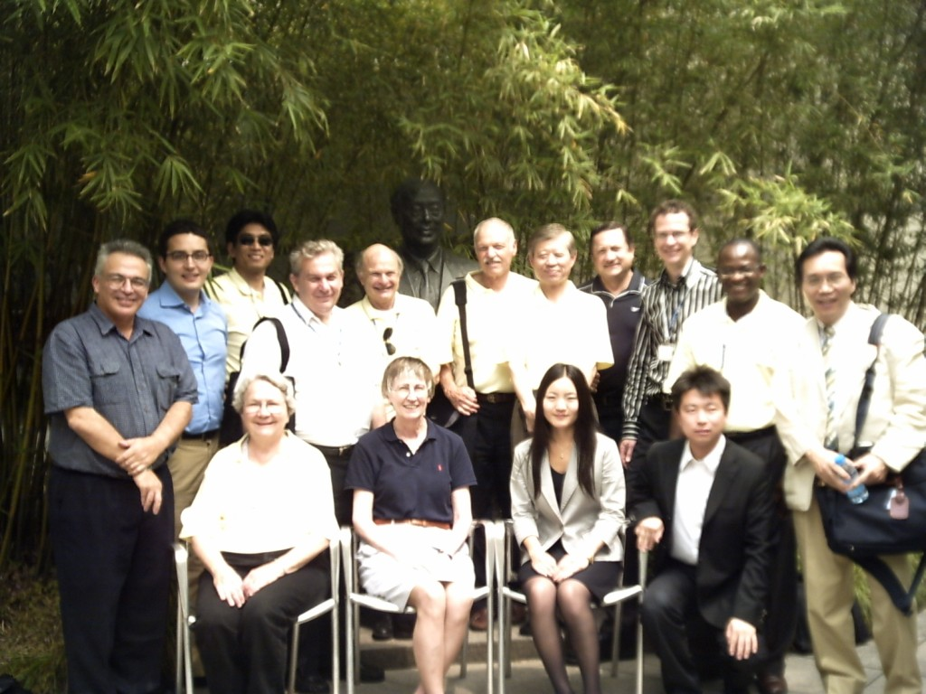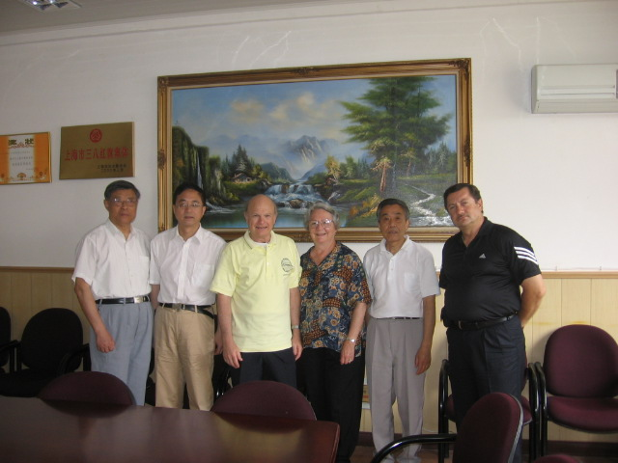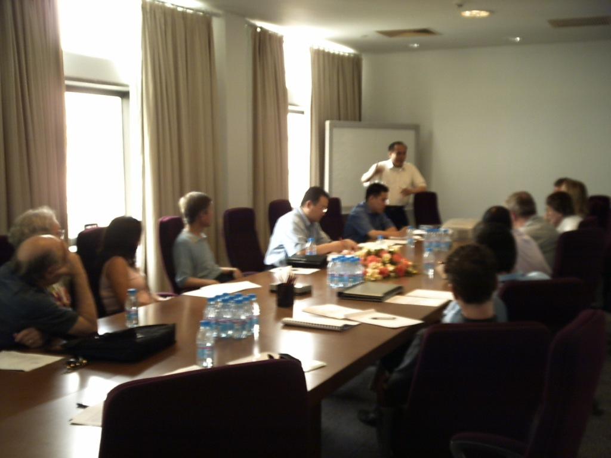
Clay, Neva, Antonio & CEIBS administrators
Guest speaker: Mr. S Wong (local manager)
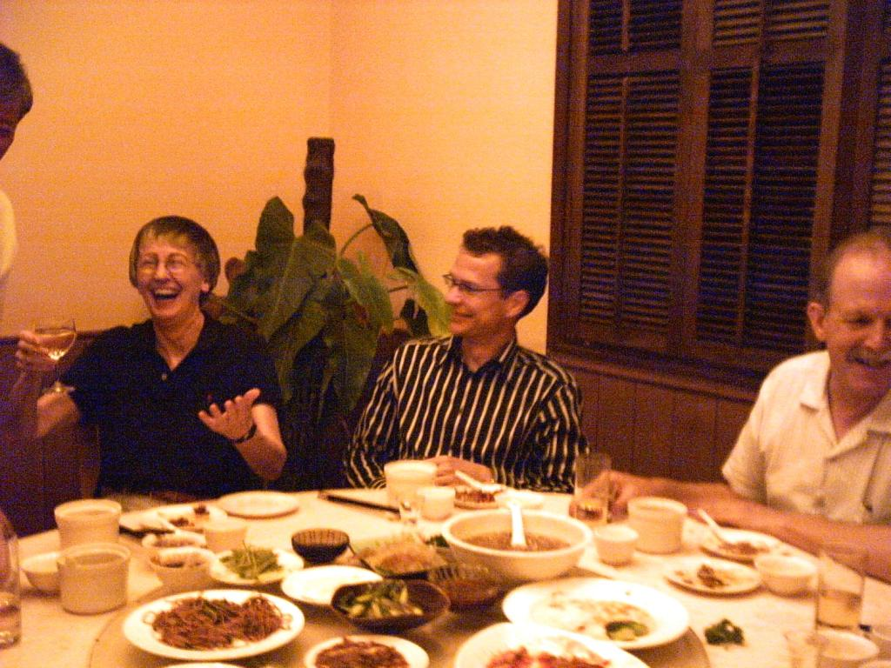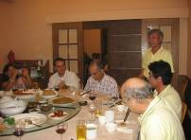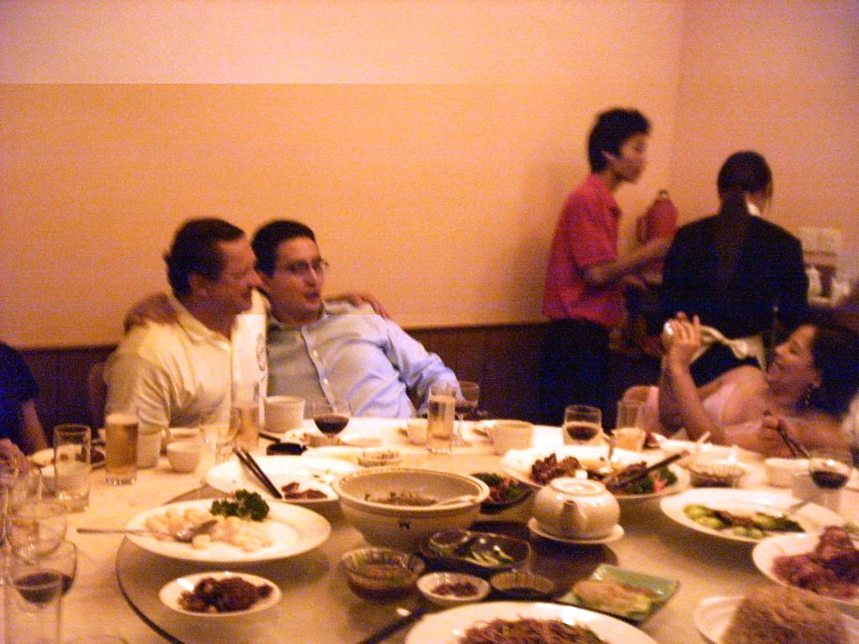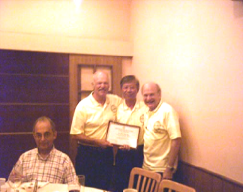
Dinner at Yang’s Kitchen (Shanghai), hosted by Dr. C-L Yang, Chung-Hua University, Taiwan.
Dr. Yang also provided commemorative shirts for the meeting.

The GMRG People Now Speak their Piece:

THE PRESIDENT’S CORNER
Danny Samson
University of Melbourne (Australia)
This is a wonderful group and its an honor to spend a year as President of the GMRG.
Its a very important year in which we must bring to fruition our data gathering efforts and get some great analysis done and papers written.
Here's a few thoughts from me about the next year or two, but I'd like to begin with a reflection on the recent past. First, a gigantic thanks to Jack Wacker who has been a fantastically active President over the past two years, and has energized a lot of us to get to where we now are.
Second, I am and will always be very grateful to Clay Whybark, our co-founder and leader for many years, who has given me the opportunity as of 1990 to get involved with this great group.
And on the subject of thanks, I want to express gratitude on behalf of all of us to Linda Sprague for hosting the 2006 meeting at CEIBS. Thanks Linda!
Looking forward, there is much productive work to do. Lets gather that data, and get on with it! We plan to take on doing a special issue of a prestigious journal (arrangements are still to be organized/finalized) in a year or so to be a home and collection for some of our research articles.
Chwen Sheu who is doing a multitude of tasks for us has taken on the job of President Elect, and will be choosing and recommending a site for the 2007 meeting. Thanks for your huge work effort Chwen. Also, please continue to work on your karaoke singing skills. I will continue to attempt to assist you in this regard but have nothing whatsoever to offer.

Mellie Pullman has stepped down from her previous role and so with a bit of coercion, Jack Wacker has agreed to step up again as VP of Data Acquisition, and will be a great source of expertise and effort in coordinating the gathering of data. Thanks Jack. And thanks Mellie for your great work to date!

Let’s keep the newsletter active and please look forward to contributing to the web blog / research forum/ bulletin board we are setting up. (Jack and Chwen are leading on that)

Please send Chwen or me your ideas for how to get the most from the 2007 meeting. I support Jack’s idea that it be an active set of research forums, where people can workshop research ideas in, say, 2 hour blocks. We will be working on this and other ideas in coming months.

One of the really great things about the GMRG is the ‘new blood’, meaning new scholars, members who come in and challenge us and refresh our knowledge. Last year at the Phoenix meeting we were delighted to have new members from South American countries, European countries, USA and Japan. This year we have more from Europe and strong interest from USA, more South Americans, a couple of my colleagues from ‘down-under’ joining in our efforts and many others. I have learned a great deal from being a part of GMRG, and at the same time enjoyed the collegiate atmosphere, which we must continue and blend with our work output. An example is that at the conference dinner at Dr. Yang’s fabulous restaurant in Shanghai, I was so privileged to sit at a table and swap stories, about everything from manufacturing competitiveness to World Cup soccer, with great people from pretty much every continent!

Happy data gathering, and of course TYA!

Danny Samson

DIRECTOR’S CORNER
Clay Whybark
University of North Carolina (USA)

Oh, hi there! Glad you could join us! Neva (my wonderful wife and “mother” of GMRG) and I had a great time in Shanghai this summer. Some of you will remember that we lived in Shanghai while I taught at the Shanghai Institute of Mechanical Engineering more than 20 years ago. Since the GMRG meeting was held at the Chinese European International Business School (CEIBS) in Pudong, it gave us an opportunity to revisit that part of the city. It was in Pudong that we used to ride bicycles among the rice paddies and the eel farms (yes, they raised them to sell to restaurants in “the city”). For those of you that were there for the meeting, it is impossible to describe what the changes were like. The extent of development in the area is unreal. The rapidity of change is so great that even those who live there can see it.

Thanks to the good efforts of Arturo Macias, we got to visit our old stomping grounds, which are now known as the University of Shanghai for Science & Technology. Arturo and Xiao Cheng Zhong were among the first GMRG exchange professors, having visited each other’s campuses several years ago. Moreover, Xiao Cheng Zhong was a close colleague when we were at his university. He and another professor at the university, Dai Ming Zhong, were among the first collaborators in the GMRG data gathering effort and sponsored a meeting in 1990 of the group in Shanghai. While on campus, we met with the Dean of the Business School and Professor Xiao. Professor Dai Ming Zhong, long since retired, still lives on the campus, but we didn’t have a chance to see him.

There were unbelievable changes in the campus. Gone is the factory that played “The Sun Rises in the East” every morning to wake up their workers (and those of us that had adjacent apartments). There are a great number of new buildings and a whole new sense of purpose and direction at the university. In the “ordinary life” category, we got to hail a taxi from the street. When we lived there it required a 24-hour advance reservation to get a taxi. Anyway, you get the picture. Unbelievable changes have occurred in a very short period of time. If the rise of modern Shanghai is any example, hang on to your hat, we’re in for a ride.

But that is enough of our reminiscing. The POM meeting, co-chaired by Linda Sprague, was a fine success. As tag-alongs, GMRG enjoyed the hospitality of CEIBS and the kinship of the POMS participants. The progress GMRG has made over the last few months has been notable and Jack Wacker deserves a great deal of credit for moving us forward. During the meeting at CEIBS, we had sessions in which we discussed the current modules of the survey, interest in participation from several new countries and techniques for improving yield on the administration of the survey. Several people, new to our activities, were introduced to the special brand of GMRG camaraderie and had their arms twisted to get involved with the group.

A very special event was an outstanding meal hosted by Dr. Yang at his restaurant, Yang’s Kitchen, in Shanghai. Not only did he treat us to a great meal, but he provided us with commemorative shirts for the meeting. Not only was the meal at Yang’s Kitchen outstanding but we learned something about the “chug-a-lug” capabilities of our host and a very slight Japanese woman. You’ll just have to ask one of us at the next meeting if you want more details. To have the opportunities to be associated with such wonderful and generous people is a major benefit of being associated with the Global Manufacturing Research Group. And you thought it was all about research.

At our formal meetings in Shanghai, the mantel of President passed from Jack Wacker to Danny Samson. Danny is already making plans for the next meeting and for continuing the expansion of data gathering that was initiated by Jack. Chwen Sheu was selected as President Elect, which means we will continue to benefit from all his fine work for the organization. All in all it was a very successful meeting. Thanks to all of you that were there and to those that weren’t; I hope you’ll be able to join us next year. Stay tuned for future plans.

MESSAGES FROM THE VICE PRESIDENTS

In the following paragraphs, several vice presidents have addressed their functions and provided relevant news.

VP OF MEMBERSHIP
Chwen Sheu
Kansas State University (USA)

1. 2006/2007 Membership fee
It is time to renew your membership. The following members paid for their dues at the Shanghai meeting. Thank you.

C. Whybark, D. Samson, J. Wacker, C. Sheu, L. Sprague, M. Kalchschmidt, P. Jonsson, C-L. Yang, A. Chiuan, A. Macias, M. Ota, T. Callerman, I. Ehie.

New members: B. Fynes, I. Gavronski, J.E. Fensterseifer, S. Pereira, S. Abbas, Y-U, Cui, M. Kanako, Y. Shi.

We would like to again welcome the new members to the family. For those who have not paid their fee, please use the attached form to do so. Thanks.

2. GMRB Website
There are obviously many things we can do to upgrade the website. Jack has made suggestions and he is going to help me with additional changes. At this moment, what I plan to do is the following:
- Update the Round 4 data collection progress. If you are data collectors, please give me the update.
- Create a new web link showing the research projects that are using the newly collected data.
- Post photos and related information from the 2006 Shanghai meeting. For those who took pictures while in Shanghai, please send me what you would like to post on the web.

3. 2007 GMRG Meeting
You might have received the RFP for the 2007 meeting. Yes, we just finished the 2006 meeting but we do need to begin to think about the future. Subject to agreement from the Executive Board and input from you, the meeting could well be dedicated to WRITING PAPERS using the GMRG IV database. Don’t worry, we will still have fun, as always, but we could organize the meeting in such a way that the members come to the meeting with prior arrangement and communication with each other regarding potential research collaboration. A substantial part of the meeting will then be dedicated to analyzing data and preparing drafts. Sound like a good idea? Please let me know.

VP - DATA ACQUISITION
Jack Wacker
Arizona State University (USA)

Hello GMRGers! Danny has asked me to act as Vice-President of Data Acquisitions and I have agreed more or less reluctantly.

First, here is an update on data collection. Data collection is still in its early stages. In my recent e-mail survey, there are 23 countries that are in various stages of data gathering. Some have completed, some are still gathering, some are preparing to gather, some are translating. There are still four or five countries that have not responded but may be gathering. An update is available on our website www.gmrg.org on exactly which countries and which modules are being gathered. Please check to make sure that the modules you are gathering is correct.

Although there is a web-based version of the survey, almost all respondents have used the paper version. We are still linking the web-based version to the web page so we can use it if necessary.

There has been a change in the effort needed to get factory managers to respond due to the increase in empirical research the classic questionnaire overload. Consequently, mailing out large number of questionnaires in the USA or other advanced countries has not been effective in getting a large number of respondents. Classical data gathering methods are still effective. Getting the respondent to agree before sending out the questionnaires, follow-up phone calls, double checking with the respondent on questions, etc., have all been fairly effective. Naturally, respondents want to have comparisons with other organizations for their efforts. Data gatherers need to develop the comparison within their sample and send it with the thank you note. Overall, we still need to have an international comparisons standard report to give the factory managers that have devoted their efforts to responding to the questionnaire. This report probably should be separate from the sample response.

There are many issues that need to be addressed among these issues are:

1. Several researchers wish to gather the absolute minimum number of questionnaires and wish access to all the larger samples. Naturally the data gatherers with large sample own the data and may not wish to distribute their data to the small sample data gatherers. We need to address this issue to be fair to those researchers that gathered large samples with large costs. So the issue is how do we distribute data to people that have small samples?

2. When a data gatherer has a sample, how many researchers should the data gatherer share his/her data with? For example, a data gather gets 50 samples can that data gatherer share an entire GMRG data set with a team on 5 or 6 other academics that have not actively gathered the data? Should the only people that have access be the gatherers that have actively gathered data?

3. When the data gathering is completed, gatherers can enter it in standard format. This format is available on our website www.gmrg.org. It can be sent to me. When, I receive it, I will begin to distribute it to data gathering researchers on the modules in which they have gathered data. Please e-mail to j.wacker@cox.net .

Remember the 2007 GMRG Meeting will focus on writing research papers for top journals. The meeting will be a true research workshop.

John “Jack” Wacker

GMRG RESEARCH PAPERS
(Members, please continue to send me your GMRG publication information.)

- Pagell, M., Krumwiede, D.W. & Sheu, C. (forthcoming). Efficacy of environmental and supplier relationship investments - Moderating effects of external environment, International Journal of Production Research.
- Wacker, J.G. Yang, C.L. & Sheu, C. (forthcoming). Productivity of production labor, non-production labor and capital: An international study. International Journal of Production Economics, 103(2), 863-872.

- Wacker, J.G. & Sheu, C. (2006) Effectiveness of manufacturing planning and control systems on manufacturing competitiveness: Evidence from global manufacturing data. International Journal of Production Research, 44(5), 1015-1036.
- Pagell, M., Katz, J.P. & Sheu, C. (2005). The importance of national culture in operations exploratory study of decision-making, International Journal of Operations & Production, 25(4), 371-394. (2005 Emerald Network Awards for Excellence Outstanding Paper)
- Schmenner, Roger W., and Gyula Vastag, “Revisiting the Theory of Production Competence: Extensions and Cross-Validations.” Journal of Operations Management, forthcoming.
- Vastag, Gyula, and D. Clay Whybark, “Inventory Management: Is There a Knock-On Effect?” International Journal of Production Economics, vol. 93-94 (January 2005), pp. 129-138.
For articles over 2 years old, please view them on the WEB at:
http://www.gmrg.org/

Way to Go!!!!!!!!

A LITTLE GMRG HISTORY
Repeated for new members

One important issue related to the culture of an organization is its historical development. Many folks who have been with this awesome group already know of the events that have lead to such a fine organization. Those of us new to the group may not have all of the details, some of which we may not want to know about ☺. However, I know that I have been intrigued with the GMRG development process. Therefore, Neva Whybark and Amrik Sohal have been providing information that should give us “green horns” (an old western cowboy saying for those not yet experienced) some insight. Several articles pertaining to the history of GMRG have been written. With that in mind, the following is the beginning of hopefully a series of facts and stories that relate to GMRG.

The Global Manufacturing Research Group (GMRG) has been in existence as an organization for over 20 years. It has its beginnings in 1985. From discussions at a conference in Seoul, Korea, Boo Ho Rho and Clay Whybark afterwards created the first questionnaire to compare manufacturing practices in Korea and the Peoples Republic of China where they were at that time. Others also became interested in collecting such research data in other countries where they lived or had lived as they learned about the research project at various meetings and by word of mouth. As research papers were presented at meetings around the world, the GMRGers attending held meetings to discuss and share findings, problems and solutions or possible solutions regarding data gathering, analysis, etc. Various members have hosted GMRG meetings in their countries in conjunction with or apart from other formal professional groups such as POMS, EurOMA, DSI, Pan Pacific Conference, and others.

The group produced a second round survey in the early 1990’s. Many of the questions were the same as the first survey with a significant number of questions either added or modified to represent changes in the field of operations since the first survey. The same methodology as for the first survey was utilized to collect and distribute data. Once again, journal articles were produced.
The Global Gazette
The Global Gazette is the Official Newsletter of The Global Manufacturing Research Group.
CIBERS
Professor Danny Samson, President
Professor Dennis Krumwiede, Gazette Editor

In the late 1990’s a third round survey was developed to allow for new and updated research efforts. Data from this survey became available for research use in late 2004 and early 2005 by contributors from GMRG. Much effort is being placed into understanding the results of the data collected. Around the same time the third survey data became available for research use, a fourth survey was in the process of being released for data collection and future analysis. As for previous surveys, GMRG members are in the process of administering the survey around the world. It is anticipated that data obtained from this effort should be available in the mid to late 2000’s for analysis first by the data gatherers and GMRG members. Later others will also be able to use the data gathered

Membership in GMRG has increased over the years as the group’s research efforts became known to the academic and industrial sectors. Members in or from more than ten countries are involved in global data collection using the latest questionnaire.

Note from the edtor: If you are getting more and more curious about the history of GMRG as I am, then you can read the following articles:

Global Manufacturing Practices: A Worldwide Survey of Practices in Production Planning and Control, (edited with G. Vastag) Elsevier, Amsterdam, 1993

What is GMRG and Why are These People Smiling?” (with K.A. Brown) DSI Newsletter, February-March, 1998

HAVE NEWS, LET US KNOW

Please feel free to let us know of any GMRG related news that you would like to have added to the next issue of the Gazette. Such information is greatly appreciated.

Attachment # 1


Assessing global competitiveness of manufacturing supply chains through an international alliance of leading universities

Membership Fee for August, 2006 until the 2007 GMRG Annual Conference

Name (print or type): .

Last First Middle
Your Name
Department
University
Street Address (P.O Box):
City, State
Country:
Business Phone:
FAX
Home Phone
e-mail:

Registration Type | Fee | Fee Selected
Membership Registration (a one-year GMRG membership) | US$ 50
Student Registration (a one-year GMRG membership) | US$ 25
Total Registration Fee: |  | US$

Payment by CHECK

Payment by CREDIT CARD (Master Card or Visa only)
Your Name as appears on Card
Type of Card
Name on card
Card Number:
Expiration Date:
Signature for credit card payment:

Make out to: GMRG C/O University of Melbourne, and send (with this form) to: Prof. Chwen Sheu by email, csheu@ksu.edu, fax: +1 785 5321339, or 101 Calvin Hall, Kansas State University, Manhattan, KS 66506, USA.

